Algebra 3-4 Name

Block___ Date

**Unit 9 Assessment**

**Determine whether each function is an example of exponential growth or decay. (L2)**

1. 2.

1. 2.

3. You put $2000 into an account earning 4% interest compounded continuously. Find the amount in the account at the end of 8 years. (L3)

3.

4. Robert invested $800 in a bank account. The account has an annual interest rate of 5.5%. How much money will be in the account after 12 years? (L3)

4.

5. The population of a bee colony is declining at a rate of 2.3% each year. There are currently 10,200 bees in the colony. How many bees will there be in 5 years? (L3)

5.

6. A parent increases a child’s allowance by 15% each year. If the allowance was $3 on the child’s 5th birthday, how old will the child be when the allowance is $15? (L4)

6.

**Graph each function. (L3)**

7. 8.

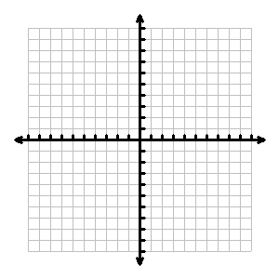

9. Write the equation in exponential form. (L2)

9.

10. Write the equation in logarithmic form. (L2)

$7^{3}=343$ 10.

**Evaluate each logarithm. (L2)**

11. 12. 13.

14. 15. 16.

**Write each logarithmic expression as a single logarithm. (L3)**

17. 18.

19. Use the Change of Base Formula to evaluate the expression. (L2)

$\log_{7}{42}=$

**Solve each equation.**

20. (L3) 21. (L3)

20. 21.

22. (L3) 23. (L4)

22. 23.